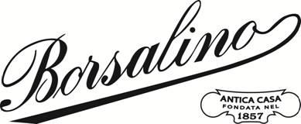

INTRODUCING THE BORSALINO X CHLOÉ CAPSULE COLLECTION
Originating from a mutual respect for craftsmanship and flair for creativity, the Borsalino X Chloé capsule collection of hats evokes the free-spirited nature of summer.
Introducing the debut Borsalino X Chloé capsule collection of hats, which is inspired by the joy, freedom, and spontaneity of the summer season. The capsule collection features two hats that seamlessly combine Borsalino’s unrivaled millinery expertise and Chloé’s singular vision of elegance and femininity.
The two hat designs are handcrafted from natural straw by Borsalino’s Italian artisans complete with signature Chloé details. The Woody Panama hat is hand woven entirely from natural straw and features a cotton-linen Chloé logo ribbon reminiscent of its Chloé bag namesake.​ The straw hat meanwhile has a tailored leather belt and C-shaped brass buckle.
“We are thrilled to present the Borsalino X Chloé capsule collection,” says Mauro Baglietto, Managing Director of Borsalino. “This collaboration aligns and reflects our ongoing mission to push beyond the horizons of handcrafted luxury to renew our extraordinary heritage.”
Borsalino, the maximum expression of Italian excellence in the production of hats, continues its current strategy of translating its DNA into contemporary aesthetic codes and projects its iconic symbol of elegance and style with 166 years of history into the future.
For over 165 years Borsalino – founded in 1857 by Giuseppe Borsalino making it the oldest luxury hatmaker in Italy – has been paving the way in millinery savoir-faire, all the while harnessing its rich heritage to define the future of hatmaking.
The Borsalino X Chloé capsule collection is available from June 26th, 2023, in Borsalino’s flagship boutiques.

Borsalino Press Office  Via della Spiga 30 - 20121 Milan, Italy  +39 02 86463028  pressoffice@borsalino.com | www.borsalino.com  @borsalino_world

